
Smart Campus Shuttle System

Initials | Surname | Student No.
S | Mdletshe | 22317991
SB | Ntuli | 22438195
S | Mngoma | 22327734
AM | Mbambo | 22305677

Graph from the Hash Map

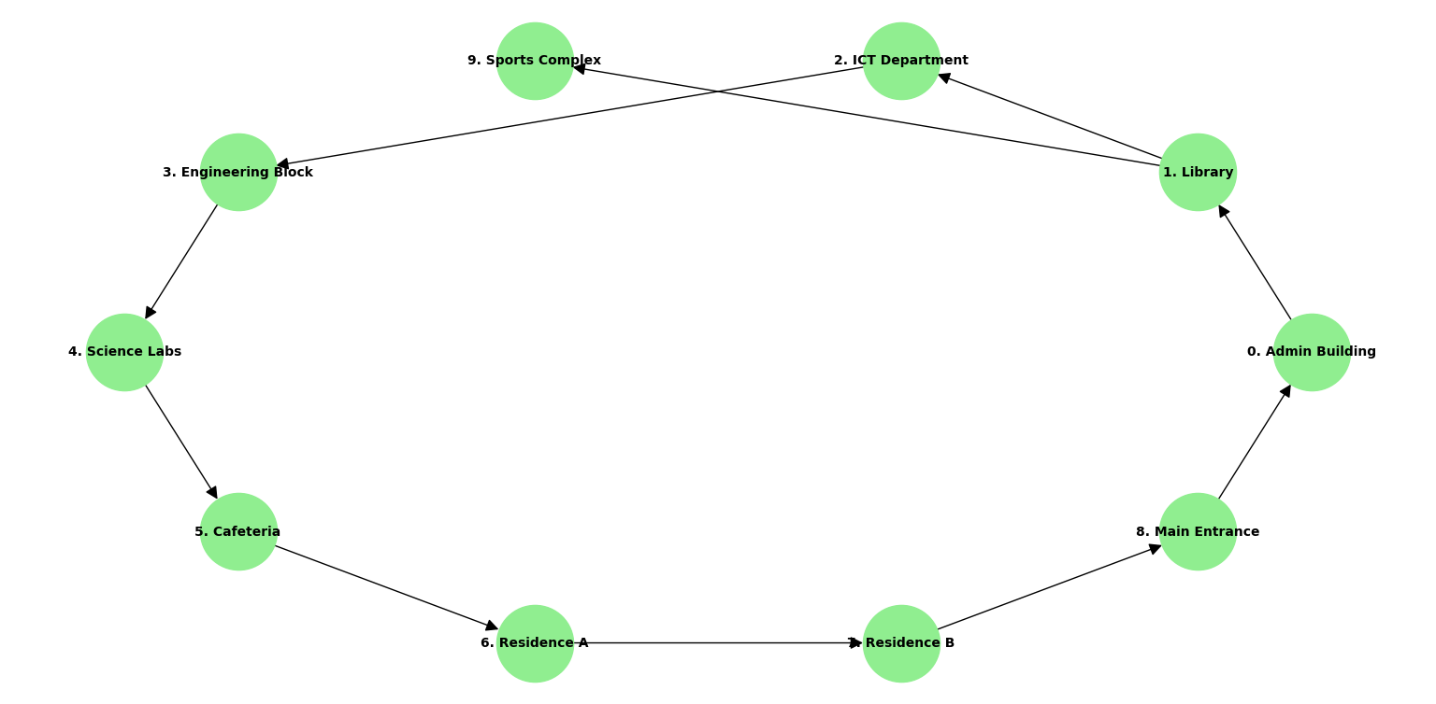

Adjacency Matrix Table: Smart Campus Shuttle System

From / To | 0 | 1 | 2 | 3 | 4 | 5 | 6 | 7 | 8 | 9
0 | 0 | 1 | 0 | 0 | 0 | 0 | 0 | 0 | 0 | 0
1 | 0 | 0 | 1 | 0 | 0 | 0 | 0 | 0 | 0 | 1
2 | 0 | 0 | 0 | 1 | 0 | 0 | 0 | 0 | 0 | 0
3 | 0 | 0 | 0 | 0 | 1 | 0 | 0 | 0 | 0 | 0
4 | 0 | 0 | 0 | 0 | 0 | 1 | 0 | 0 | 0 | 0
5 | 0 | 0 | 0 | 0 | 0 | 0 | 1 | 0 | 0 | 0
6 | 0 | 0 | 0 | 0 | 0 | 0 | 0 | 1 | 0 | 0
7 | 0 | 0 | 0 | 0 | 0 | 0 | 0 | 0 | 1 | 0
8 | 1 | 0 | 0 | 0 | 0 | 0 | 0 | 0 | 0 | 0
9 | 0 | 0 | 0 | 0 | 0 | 0 | 0 | 0 | 0 | 0

adjacency map = {
0: [1],
1: [2, 9],
2: [3],
3: [4],
4: [5],
5: [6],
6: [7],
7: [8],
8: [0],
9: []
}

